



|  |  |
| --- | --- |
|  | **2024** |
|  | Internship Project- GarbhaGudi IVF Center  MBA BA I Year III Trimester |

**REVENUE ANALYSIS**

**ABOUT GABHAGUDI**

GarbhaGudi is a chain of new generation infertility treatment hospitals equipped with state-of-the-art infrastructure and cutting-edge technology to address this ever-increasing problem of infertility. It was founded by a team of committed entrepreneurs and healthcare specialists, led by Dr. Asha S Vijay, who is a renowned gynecologist and fertility specialist.

Contents

Project Cover Sheet 2

Introduction 3

Problem Defination 11

Data Collection 13

Analyses and Results 15

Conclusion 36

# Project Cover Sheet

|  |  |  |  |
| --- | --- | --- | --- |
| **Project Title** | Revenue Analysis | **Course** | MBA BA I Year – III Trimester |
| **Start Date** | 23-July-2024 | **Project Client** | Dr Lakshmi Venkatesh |
| **Date of Submission** |  | **Project Coordinators** | Dr. Eranki Lakshmana Sastry  Dr. Syed Mansoor Pasha |

**Team Members**

|  |  |  |
| --- | --- | --- |
| **SNO** | **Name** | **Roll Number** |
|  | G. Anvitha | 23MG202A13 |
|  | K. Deepthi | 23MG202A20 |

# INTRODUCTION

In the context of in vitro fertilization (IVF), revenue analysis refers to the process of examining and understanding the financial performance of an IVF center or clinic. This involves analysing the sources of income and financial inflows that the center receives from various services and procedures it provides. Key components of revenue analysis for an IVF center might include:

1. **Identifying Revenue Sources:** Understanding where the income is coming from, such as IVF procedures, diagnostic tests, consultations, fertility medications, egg retrieval, embryo transfer, and other related services.
2. **Categorizing Revenue Streams:** Classifying income into primary categories (like IVF treatments) and further into sub-categories (like initial consultations, follow-up appointments, lab tests, etc.).
3. **Doctor-wise Revenue:** Analysing how much revenue each doctor or specialist generates, which can help in evaluating the performance of individual practitioners and understanding their impact on the overall financial health of the clinic.
4. **Procedure-wise Revenue:** Breaking down revenue by specific procedures or treatments to identify which services are the most profitable and which may need optimization or promotion.
5. **Trend Analysis:** Looking at revenue data over different time periods to identify trends, seasonality, or patterns in demand for specific services.
6. **Financial Performance Metrics:** Calculating key metrics such as average revenue per procedure, per patient, or per visit to assess the efficiency and profitability of the clinic's operations.
7. **Comparative Analysis:** Comparing revenue across different periods, between different doctors, or against industry benchmarks to gauge performance and identify areas for improvement.
8. **Forecasting and Planning:** Using historical revenue data to forecast future income, plan resource allocation, and make informed business decisions.

Overall, revenue analysis helps an IVF center understand its financial health, optimize its services, and strategically plan for growth and sustainability.

# Overview

Revenue analysis in the context of in vitro fertilization (IVF) involves examining the financial performance of an IVF clinic. It identifies the main sources of income, such as IVF procedures, consultations, and tests. This analysis categorizes revenues into different streams to understand which services generate the most income. It also looks at revenue generated by individual doctors and specific procedures. The goal is to identify trends, measure financial performance, and compare against industry standards. Revenue analysis helps clinics optimize operations, allocate resources effectively, and plan for future growth by forecasting potential income. It ultimately ensures the clinic's financial sustainability and success.

**1. Purpose of Revenue Analysis:**

* To assess the financial performance of an IVF center.
* To identify key income sources and their contribution to overall revenue.
* To support strategic decision-making and financial planning.

**2. Key Components:**

* **Revenue Sources:** Identifying and categorizing different streams of income, such as IVF treatments, consultations, diagnostic tests, medications, and ancillary services.
* **Doctor-wise Revenue:** Analysing revenue generated by each doctor to evaluate individual performance and contribution to the clinic’s earnings.
* **Procedure-wise Revenue:** Understanding which procedures or treatments are most profitable, helping to optimize service offerings.

**3. Benefits of Revenue Analysis:**

* **Financial Insights:** Provides a clear picture of where the clinic’s money is coming from and which services are most lucrative.
* **Operational Efficiency:** Helps identify areas for cost reduction or investment to improve profitability.
* **Strategic Planning:** Informs decisions on pricing, marketing, staffing, and service expansion based on financial data.

**4. Methods:**

* **Data Collection:** Gathering financial data from billing systems, accounting records, and patient management systems.
* **Analysis Techniques and Statistical Modelling using Python:** Using tools like spreadsheets, business intelligence software, and dashboards to visualize and interpret revenue data.
* **Trend and Comparative Analysis:** Examining revenue trends over time and comparing them against industry benchmarks or historical performance.

**5. Outcomes:**

* Improved understanding of the clinic’s financial health.
* Enhanced ability to make data-driven decisions.
* Increased profitability through better resource allocation and service optimization.

Revenue analysis is essential for IVF centers to maintain financial stability, improve operational efficiency, and support long-term growth strategies.

# Objective

The objective of this project is to categorize and analyze revenue sources, providing drill-down capabilities for detailed insights, and to develop a dashboard that displays doctor-wise and procedure-wise revenue with filters for time periods, enabling comprehensive revenue analysis and informed decision-making.

# Background

In vitro fertilization (IVF) centers provide specialized fertility treatments and services to help individuals and couples conceive. As the demand for these services grows, it's crucial for IVF centers to monitor their financial performance through revenue analysis. This analysis helps identify the primary sources of income, such as IVF procedures, consultations, and diagnostic tests. By understanding which services generate the most revenue, IVF centers can optimize their offerings, improve resource allocation, and enhance profitability. Revenue analysis also assists in strategic planning and ensures that the clinic remains competitive and financially sustainable.

# Importance of Revenue Analysis:

# Cost-Intensive Nature of IVF:

# IVF treatments involve significant expenses, including advanced medical equipment, highly specialized staff, laboratory work, medications, and patient care. Effective revenue management is vital to cover these costs and ensure the clinic's profitability.

# Diverse Service Offerings:

# IVF centers typically offer a variety of services beyond standard IVF procedures, such as consultations, diagnostic testing, genetic screening, egg/sperm storage, and other assisted reproductive technologies (ART). Analysing revenue helps identify which services are the most profitable and which may need better management or marketing.

# Pricing Strategies:

# The pricing of IVF treatments and related services can vary widely depending on the region, technology used, and market competition. Revenue analysis helps IVF centers optimize their pricing strategies by understanding patient willingness to pay and the competitive landscape.

# Regulatory and Market Changes:

# The fertility industry is subject to frequent changes in regulations, insurance policies, and market dynamics. Revenue analysis helps IVF centers adapt to these changes by providing insights into how different factors impact their financial performance.

# Patient Demographics and Trends:

# Understanding patient demographics, such as age, income level, and reasons for seeking treatment, can help an IVF center tailor its services and marketing efforts. Revenue analysis can reveal trends in patient preferences and treatment outcomes, guiding strategic decisions.

# Evolution of Revenue Analysis in IVF Centers:

# Early Days:

# In the early stages of the IVF industry, revenue analysis was less sophisticated, often limited to basic bookkeeping and accounting practices.

# Technology and Data Analytics:

# With the advent of advanced data analytics tools and business intelligence software, IVF centers can now perform detailed revenue analysis. These tools enable clinics to analyse data in real-time, forecast future revenue trends, and make data-driven decisions.

# Integration with Healthcare Systems:

# Modern revenue analysis integrates seamlessly with electronic health records (EHR), patient management systems, and financial software, providing a comprehensive view of the clinic's financial health.

# Focus on Patient Experience:

# Increasingly, revenue analysis is not just about numbers; it also considers patient satisfaction and outcomes. By linking financial data with patient feedback and treatment success rates, IVF centers can enhance both profitability and patient care.

**WHAT IS THE PROCESS OF IVF TREATMENT**

Here is a general overview of the steps involved in a typical IVF cycle:

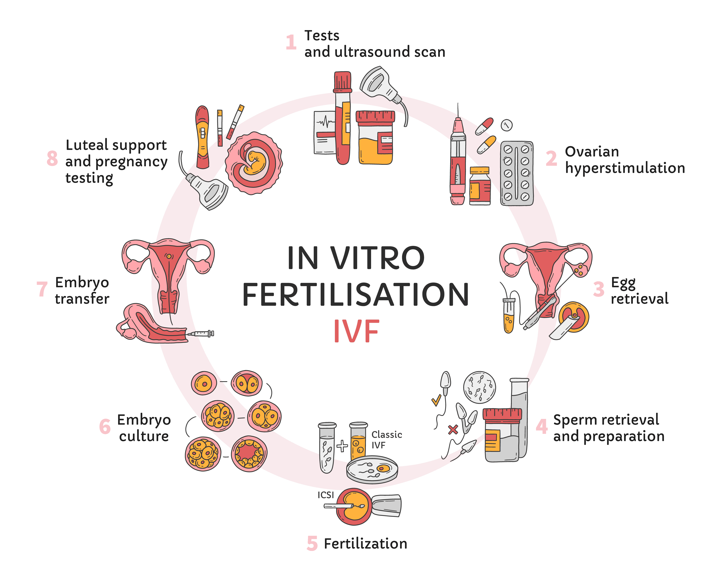

* **Initial consultation:**

The first step in the IVF process is usually a consultation with a fertility specialist. During this appointment, the specialist will discuss the person's medical history, perform a physical examination, and order any necessary tests to determine the cause of infertility.

* **Ovarian stimulation:**

The next step is to stimulate the production of multiple eggs. This is typically done using injectable medications, such as gonadotropins or gonadotropin-releasing hormone agonists. The goal is to produce several mature eggs that can be retrieved and fertilized during the IVF process.

* **Egg retrieval:**

Once the eggs are mature, they are retrieved using a procedure called transvaginal ultrasound-guided oocyte retrieval. This procedure is performed under conscious sedation or general anesthesia and involves inserting a needle through the vagina and into the ovaries to remove the eggs.

* **Fertilization:**

The retrieved eggs are mixed with sperm in a laboratory setting to allow fertilization to occur. If the fertilized eggs are deemed to be healthy and viable, they are allowed to grow for a few more days in the laboratory.

* **Embryo transfer:**

If the fertilized eggs have developed into embryos, one or more of them may be transferred to the uterus. The embryo transfer procedure is usually performed a few days after the egg retrieval procedure and involves inserting a thin tube through the cervix and into the uterus. The embryos are then gently placed into the uterus.

* **Pregnancy test:**

A pregnancy test is usually performed about two weeks after the embryo transfer procedure to determine whether or not the IVF cycle was successful. If the test is positive, the person is considered pregnant.

**WHEN IS IVF RECOMMENDED?**

Some common reasons for recommending IVF include:

* **Blocked or damaged fallopian tubes:**If the fallopian tubes are blocked or damaged, the egg may not be able to travel from the ovaries to the uterus.
* **Male fertility problems:**If the male partner has a low sperm count or poor sperm quality, IVF may be recommended.
* **Unexplained infertility:** If the cause of infertility is unknown, IVF may be recommended.
* **Ovulation disorders:** If a woman is not ovulating regularly or at all, IVF may be recommended.
* **Endometriosis:** This is a condition in which the tissue that lines the uterus grows outside of the uterus, which can cause fertility problems.
* **Advanced maternal age:** As a woman gets older, her fertility decreases, and IVF may be recommended for women over the age of 35 who are trying to get pregnant.

It is important to note that IVF is a complex and expensive procedure, and it is not always successful. It is important to discuss all of the potential risks and benefits with a fertility specialist before deciding whether or not to pursue IVF.

**FACTORS AFFECTING THE SUCCESS RATE OF AN IVF CYCLE**

There are several factors that can affect the success rate of an in vitro fertilization (IVF) cycle. These include:

* **Age:** The age of the woman undergoing IVF can have a significant impact on the success rate of the procedure. Women under the age of 35 generally have a higher success rate with IVF compared to women over the age of 35.
* **Fertility diagnosis:** The underlying cause of fertility issues can affect the success rate of IVF. For example, women with blocked fallopian tubes or endometriosis may have a lower success rate with IVF compared to women with unexplained fertility issues.
* **Quality of the eggs and sperm:** The quality of the eggs and sperm used in the IVF process can also impact the success rate. For example, if the eggs or sperm are of poor quality, it may be more difficult to achieve a successful pregnancy through IVF.
* **Number of embryos transferred:** The number of embryos transferred during the IVF process can also affect the success rate. Transferring more embryos may increase the chances of a successful pregnancy, but it can also increase the risk of multiple pregnancies and complications.
* **Lifestyle factors:** Certain lifestyle factors, such as smoking, obesity, and stress, can also impact the success rate of IVF. It is important for patients to discuss any potential lifestyle factors that may affect their fertility with their healthcare provider.
* **Embryo quality:** The quality of the embryos created during the IVF process can also affect the success rate. Embryos with high quality are more likely to implant and result in a successful pregnancy.

Overall, the success rate of IVF can vary greatly depending on these and other factors. It is important for patients to discuss their specific situation with their healthcare provider to determine the best course of treatment.

# PROBLEM DEFINATION

# This project aims to analyze and visualize revenue data to gain insights into your business's financial performance.

**A. Revenue Source Analysis:**

This section will categorize your revenue into primary sources and sub-sources, allowing you to understand where your income comes from.

**1. Categorization:**

* **Primary Sources:** These are the broad categories representing your main revenue streams. Examples might be:
  + Patient Visits
  + Surgical Procedures
  + Lab Tests
  + Doctor Fee
  + Medication Sales (if applicable)
* **Sub-Sources:** These are further breakdowns within each primary source. For example, "Patient Visits" could have sub-sources like:
  + New Patient Visits
  + Follow-Up Visits
  + Virtual Consultations

**2. Drill-Down Capability:**

The system should allow you to explore revenue data further. This could involve:

* Selecting a specific primary or sub-source to see detailed information like:
  + Revenue generated over time (daily, weekly, monthly, etc.)
  + Number of transactions
  + Average revenue per transaction
  + Reports with additional breakdowns (e.g., by insurance provider)

**Data Visualization:**

Consider using charts like:

* Bar charts to compare revenue across primary and sub-sources.
* Line charts to show trends in revenue over time.
* Pie charts (use with caution) to show the proportion of revenue from each primary source.

**B. Doctor-wise and Procedure-wise Revenue Dashboard:**

This dashboard will focus on revenue generated by individual doctors and specific procedures.

**1. Dashboard Components:**

* **Doctor Selection:** Allow users to filter data by a specific doctor. Time Period Selection: Enable users to choose a timeframe (e.g., last month, last quarter, year-to-date).
* **Doctor Revenue Chart:** Show total revenue generated by each doctor within the selected timeframe (bar chart or table).
* **Top Procedures:** Display a list of the top revenue-generating procedures for the selected doctor (optional: percentage of total revenue for each procedure).

**2. Drill-Down Options:**

* Clicking on a doctor in the chart should allow users to see a breakdown of their revenue by procedure.
* Clicking on a procedure should show detailed information like:
  + Revenue generated for that procedure.
  + Number of procedures performed.
  + Average revenue per procedure.

**Data Visualization:**

* Use bar charts to compare revenue generated by different doctors.
* Consider including a table with additional details like the number of procedures each doctor performed.

This project will provide valuable insights into your revenue streams and doctor performance. By categorizing revenue sources, analyzing doctor contributions, and providing drill-down capabilities, you can make informed decisions about resource allocation, marketing strategies, and improving overall financial health.

# DATA COLLECTION

This dataset is provided by Garbhagudi IVF Center which consist of data of the year 2020 – 2021. It involves various other different sheets which are as follows:

• **Bills Split**: This sheet contains detailed billing information, including bill codes, dates, types, amounts, and patient identifiers. It also categorizes revenue by different services like laboratory investigations, outpatient (OP) and inpatient (IP) services, pharmacy, and IVF.

• **Receipts**: This sheet lists the payments received, including receipt codes, dates, amounts, and payment methods such as card, online, and Paytm. It provides a clear view of cash flow from patient payments.

• **Bill Split - Col Split**: This sheet provides a more detailed breakdown of bills, similar to "bills split," but includes additional columns for various payment methods and advanced payment details. It appears to categorize revenue more granularly by different payment types and discounts.

• **Refunds**: This sheet documents refunds issued, including receipt codes, bill numbers, dates, amounts, and reasons for refunds. It tracks adjustments made to the financial records due to refunds.

• **Charge Items**: This sheet lists individual charge items per patient, such as IVF charges and lab tests. It includes item descriptions, categories, discounts applied, tax details, and final amounts, providing a detailed view of the services billed to patients.

The below figure shows the columns of the dataset:

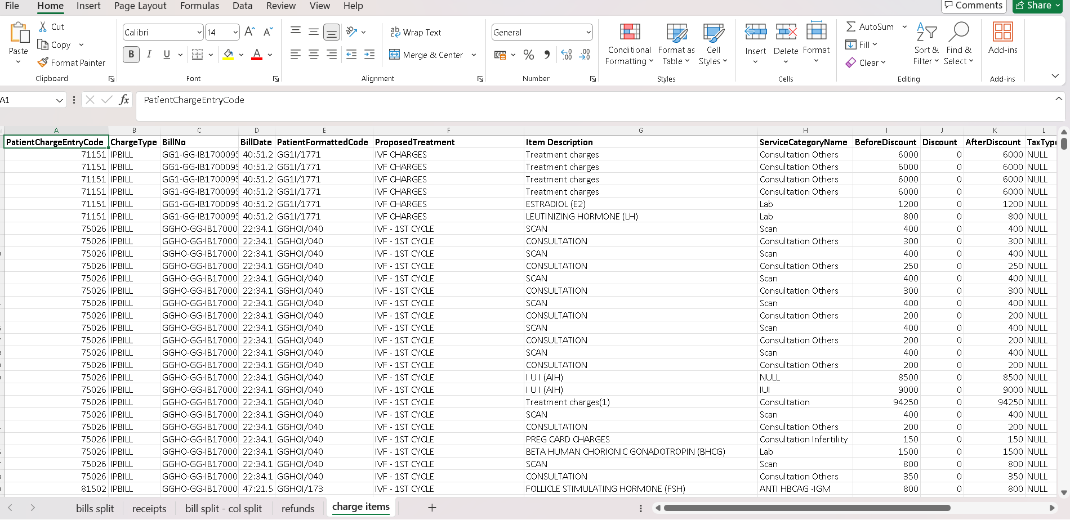

**Description of the Dataset:**

* **Comprehensive Billing Data**:

The dataset contains detailed billing information, capturing various types of services and corresponding charges.

* **Payment Receipts**:

It records all payments received from patients, along with the payment method used.

* **Detailed Revenue Categories**: Revenue is categorized by different service types, allowing for analysis by service line (e.g., IVF, lab tests).
* **Refunds Tracking**: The dataset includes a record of refunds processed, helping track financial adjustments.
* **Payment Method Breakdown**: Detailed information on payment methods is available, including card payments, online transfers, and other modes.
* **Patient Identification**: Data is linked with patient identifiers, enabling analysis of patient-specific billing and payment trends.
* **Granular Charge Details**: Charge items are broken down to the level of individual services and treatments, showing exact amounts before and after discounts.
* **Discounts and Adjustments**: Information on discounts applied and any financial adjustments is captured.
* **Tax Information**: Details about tax amounts for each charge item are included.
* **Revenue Reporting**: The dataset is structured for comprehensive revenue reporting, enabling detailed financial analysis and performance tracking.

# ANALYSES AND RESULTS

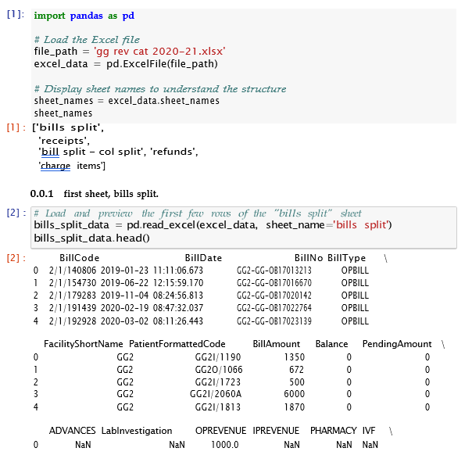

# 

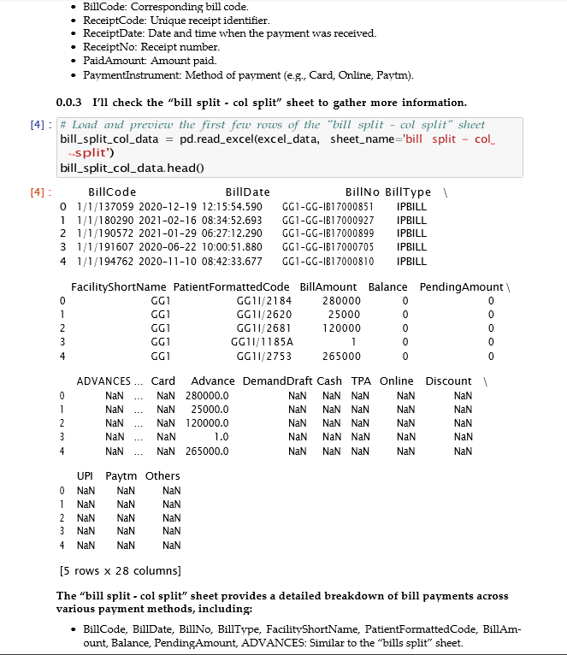

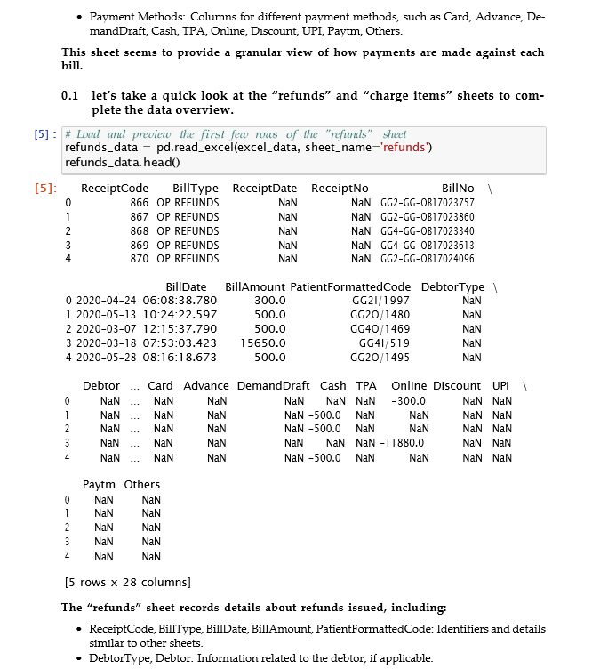

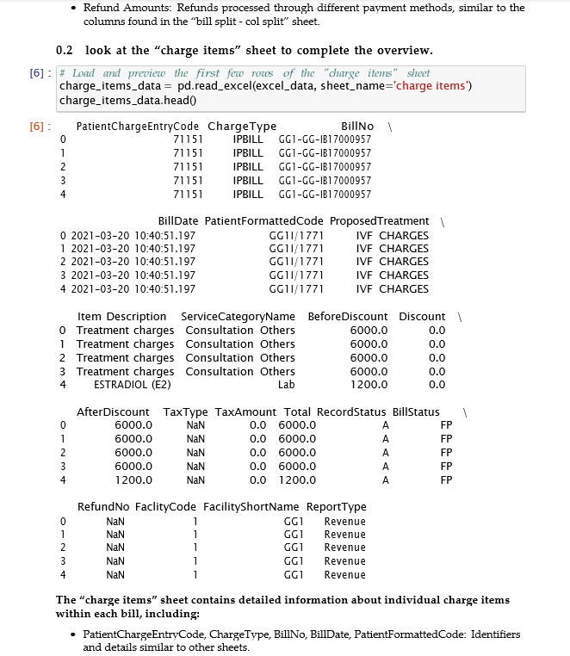

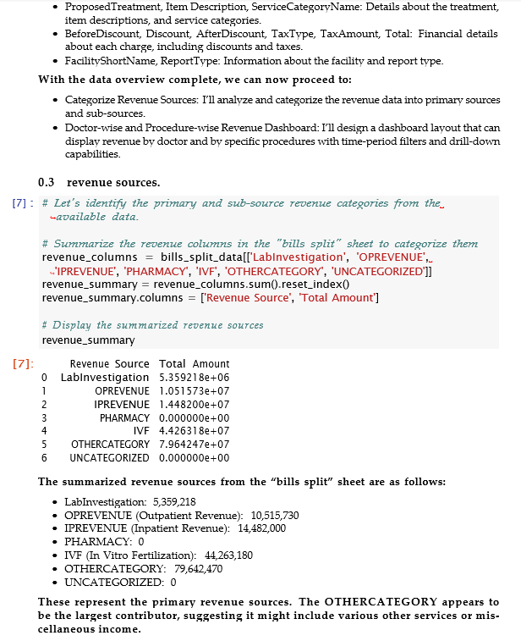

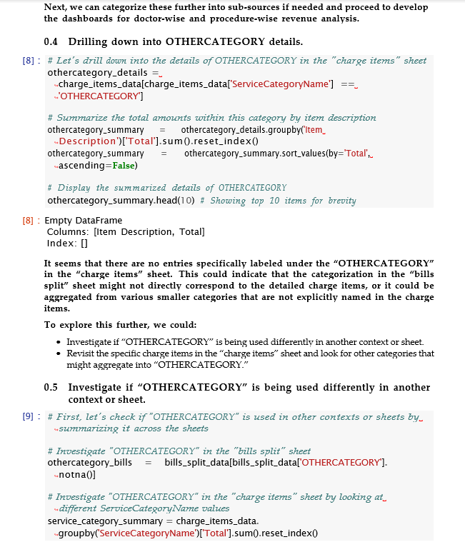

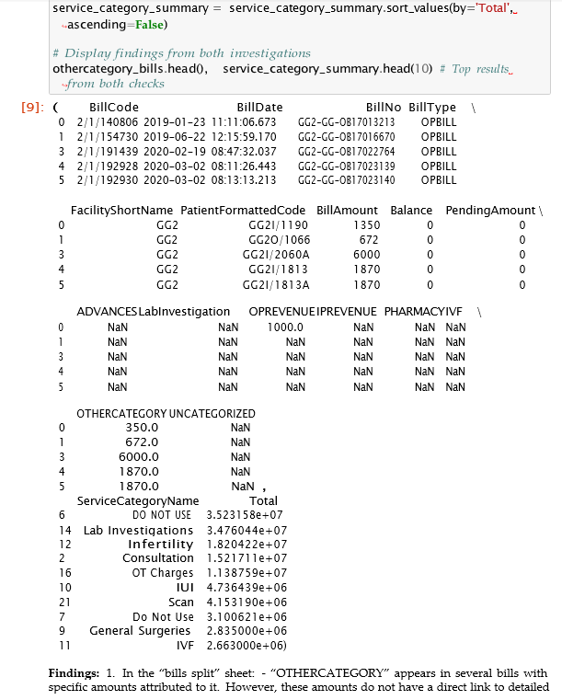

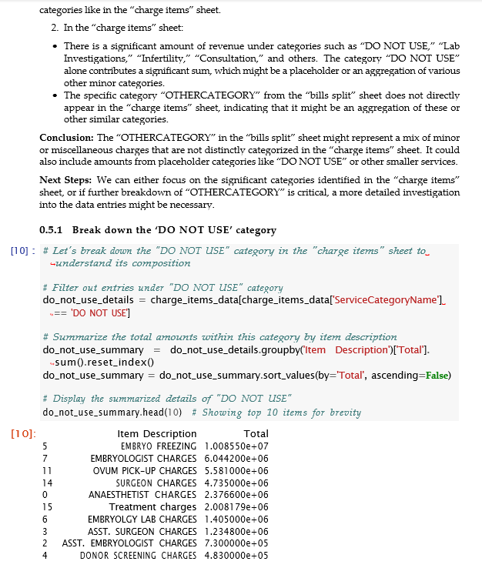

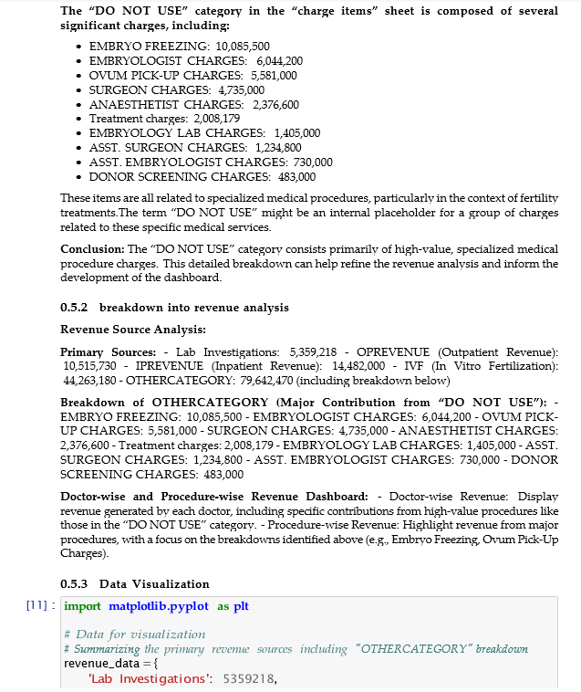

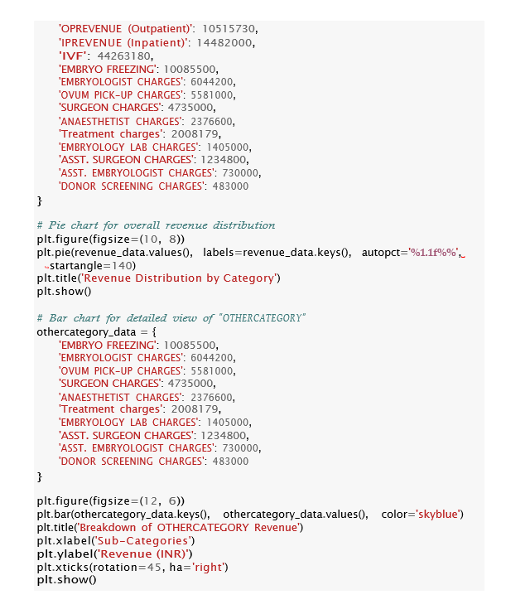

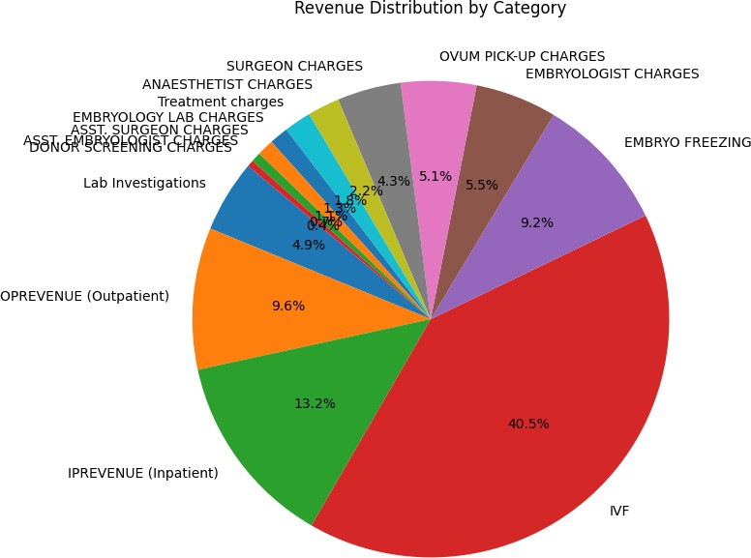

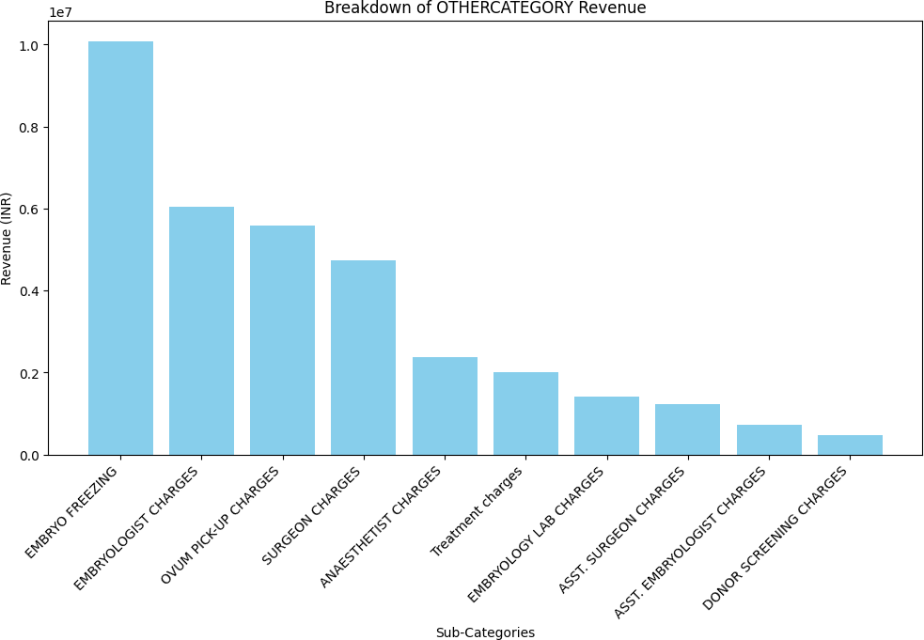

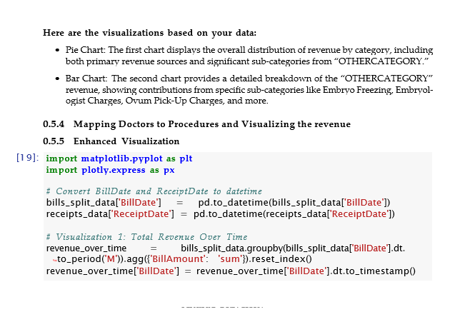

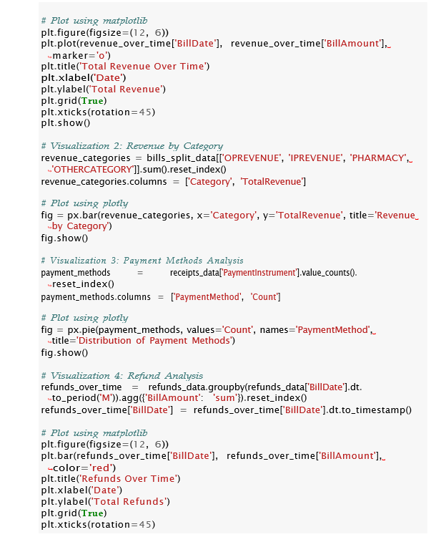







plt.show()

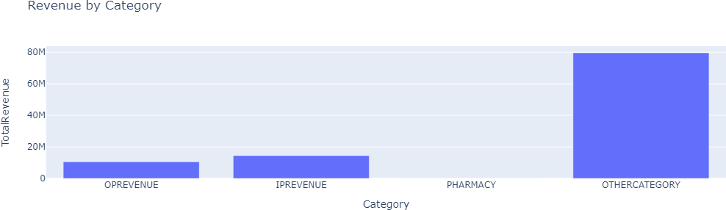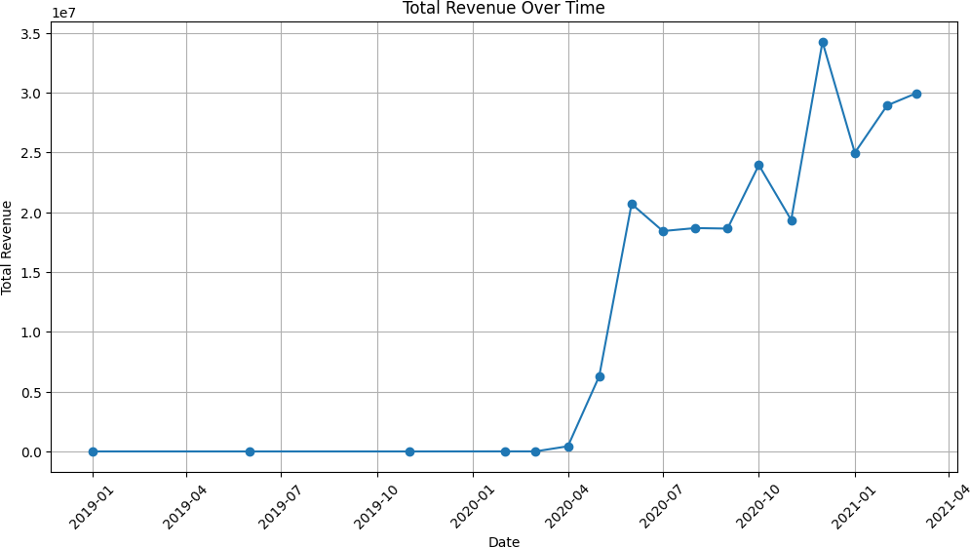

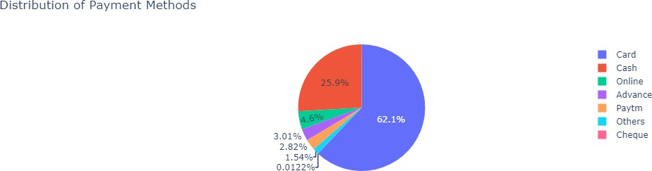

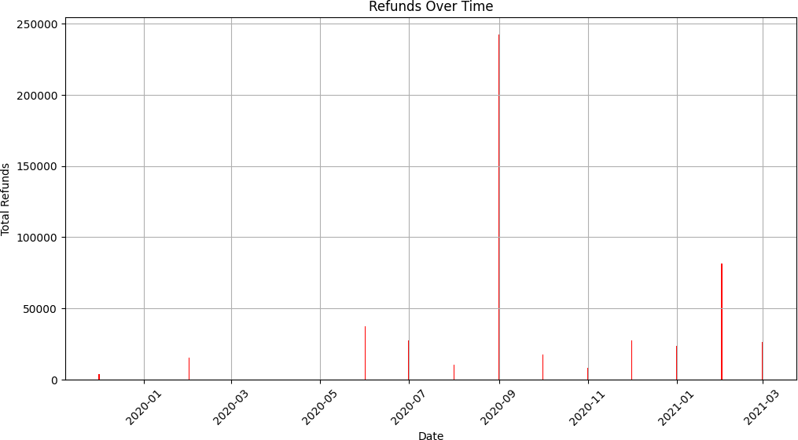

# DASHBOARD USING POWERBI

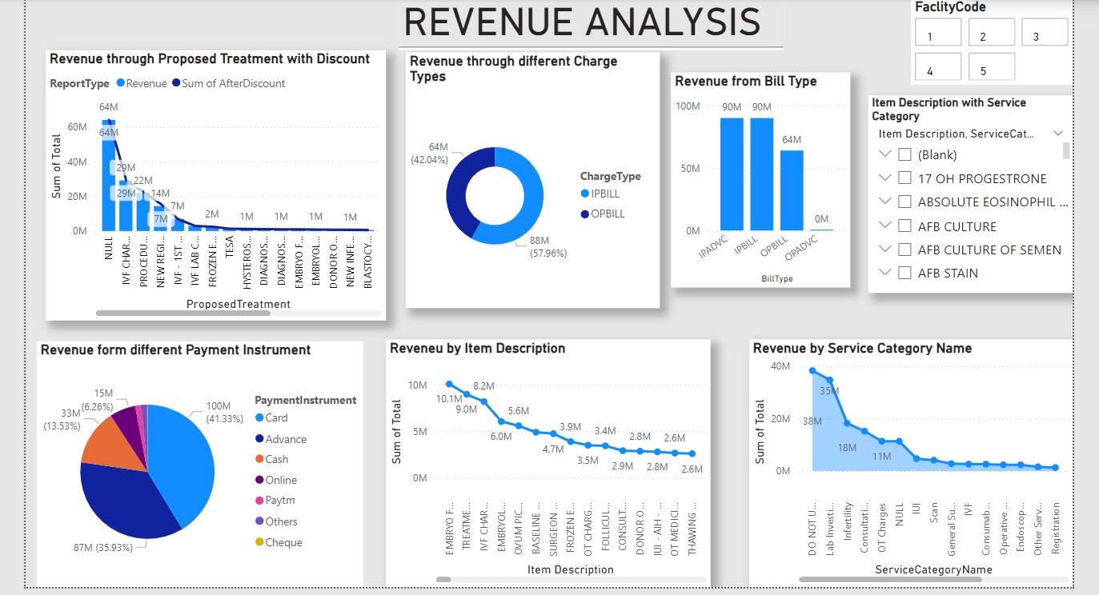

**DESCRIPTION:**

1. **Revenue through Proposed Treatment with Discount**:

This bar chart visualizes revenue analysis for various proposed treatments at an IVF center. The highest revenue, both before and after discounts, comes from "NULL" and "IVF CHARGES," each generating approximately 64M. Other significant contributors include "PROCEDURE" and "IVF/ICSI" with revenues ranging from 22M to 29M. The chart highlights a steep decline in revenue from other treatments, indicating a concentration of income in a few high-revenue services. The graph is useful for identifying which treatments are most profitable and where discounts have the most impact.

1. **Revenue through Different Charge Types**:

The donut chart shows revenue distribution between inpatient (IPBILL) and outpatient (OPBILL) charges. IPBILL accounts for a larger share (58%), indicating that inpatient services contribute more revenue compared to outpatient services (42%).

1. **Revenue from Bill Type**:

This bar chart displays the revenue from various billing categories, including IPADV, IPBILL, and OPBILL. Both IPADV and IPBILL show similar high revenue contributions of around 90M, while OPBILL is slightly lower at 64M, providing insight into how revenue is distributed across different billing methods.

1. **Revenue from Different Payment Instruments**:

The pie chart represents the revenue distribution of an IVF center across various payment instruments. The highest revenue source is from cards, accounting for 41.33% (100M). Advances follow closely, contributing 35.93% (87M). Cash payments make up 13.53% (33M) of the revenue. Online payments constitute 5.73% (14M), while Paytm, others, and cheques collectively contribute a minor share, with the lowest being cheques at 1.49% (4M).

1. **Revenue by Item Description**:

The line chart ranks revenue distribution by item descriptions at an IVF center. The highest revenue-generating item is "TESTING FREEZING" at 10.1M, followed by "EMBRYOLOGY CHARGES" at 6.2M. There is a steep decline in revenue after the top few items, with the majority of items generating between 2M and 1M. The chart highlights the significant contribution of a few key services to the overall revenue, with a long tail of less profitable items. This analysis can help identify which specific services are the main revenue drivers and where to focus strategic efforts.

1. **Revenue by Service Category Name**:

This chart, combining bars and a line, represents revenue by service category at an IVF center. The highest revenue, nearly 40M, is from the "DO NOT USE" category, followed by "Lab Investigations" at around 35M. Other significant categories include "Infertility" and "Consultation," each generating between 13M and 18M. There is a sharp drop in revenue from other categories, with most contributing less than 5M. The chart emphasizes the importance of a few key service categories in driving the center's overall revenue.

1. **Slicers**:

Slicers (Facility Code and Service Category): The slicers allow users to filter the revenue data by specific facility codes and service categories, providing a more detailed analysis based on selected criteria. These filters can help isolate revenue data for targeted evaluation and reporting.

# CONCLUSION

The dashboard provides a comprehensive overview of revenue distribution across treatments, billing types, payment methods, and service categories, enabling the IVF center to make informed decisions for growth. The IVF dashboard provides valuable insights to improve business in the future. By analyzing revenue trends, payment instrument preferences, and procedure popularity, the center can identify areas for growth and optimization. The dashboard highlights the need for marketing efforts to increase cash and online payments. Additionally, understanding the most popular procedures allows for targeted marketing and resource allocation. By leveraging these insights, the IVF center can enhance patient experience, increase revenue, and establish a strong market presence. Overall, the dashboard supports strategic planning, resource optimization, and targeted growth initiatives. The revenue analysis of the IVF center provides a comprehensive overview of the financial performance across various revenue streams. By categorizing revenue into primary and sub-sources, we gain insights into the most profitable areas. The doctor-wise and procedure-wise revenue dashboard allows for detailed examination of each doctor's contribution and the effectiveness of different procedures. Visualizations help identify trends and patterns, facilitating data-driven decision-making. Overall, this analysis aids in understanding revenue dynamics, optimizing resource allocation, and improving financial strategies to enhance the center's profitability.